Navigating the Financial Aid Process: Insights from California’s High School Class of 2023
Elizabeth Friedmann, Jaime Ramirez-Mendoza, Michal Kurlaender, Paco Martorell, Stefano Cantos, Jessica Moldoff and Ryan Fuller
April 2024

Many low-income students still face financial barriers when making decisions about enrolling in college. Receipt of financial aid has been linked to increased college enrollment, persistence, and graduation (Bettinger et al., 2012; Dynarski et al, 2022); yet, the complexities of the financial aid process - particularly the Free Application for Federal Student Aid (FAFSA) - continue to pose a persistent hurdle for students (Bahr et al., 2018; CSAC, 2023). Students must complete this crucial first step in order to begin the process of receiving any federal financial aid (including the Pell Grant and Direct Loans), but many fail to successfully apply due to the length and complexity of the FAFSA.
To address this critical component of the college enrollment process, the California State Legislature passed Assembly Bill 429 with the goal of expanding financial aid access to students who may otherwise be unaware of their aid eligibility. Beginning in 2022-23, California high school seniors are required to submit the FAFSA or California Dream Act Application (CADAA). California is now among several states that require high school seniors to submit a FAFSA for graduation - including Louisiana, Texas, Alabama, Illinois, New Hampshire, and Connecticut (NCAN, nd).
In light of this new requirement and ongoing complexities of financial aid processes, the California Education Lab at UC Davis partnered with the California Student Aid Commission (CSAC) to survey high school seniors from the class of 2023 to ask about their experiences with the financial aid process. In this report, we describe how students experienced the new FAFSA/CADAA requirement, their sources of support for understanding and submitting the application, and their plans to pay for college. We investigate differences across student income, race, and intended type of college enrollment. We also explore how students described — in their own words — the barriers and concerns related to financial aid, and how that could impact their transition to college.

About the Survey [TEXT BOX]
In partnership with the California Student Aid Commission (CSAC), the California Education Lab at UC Davis designed and administered a survey to the full population of California high school seniors who submitted a FAFSA/CADAA for the 2023-24 academic year. Using a mix of Likert-scale, select response, and open-ended questions, the survey asked about students’ experiences with the financial aid process, what support(s) and information students received about financial aid, and their existing worries in financing college. The survey was sent via email and was open from mid-May to mid-June, 2023. The sample of survey respondents includes more than 10,000 respondents with valid email addresses to be able to link to their FAFSA/CADAA information, resulting in a response rate of 4%. Despite a low response rate, given the newly mandated FAFSA/CADAA submission (and large sample size), students applying for financial aid offer a more representative picture of the graduating class compared to prior years. Drawing on an existing data-sharing agreement between the California Education Lab at UC Davis and CSAC, individual survey responses were linked to administrative and financial aid records held by CSAC, allowing further analysis of differences by expected family contribution (EFC), race, and where students planned to attend college (CCC, CSU, UC).

New FAFSA/CADAA Requirement
The statewide requirement for high school seniors to complete the FAFSA/CADAA went into effect for the 2022-23 academic year. Figure 1 shows that overall, 8 out of 10 students reported being required by their high school to fill out the FAFSA/CADAA, but this varied by subgroup. Almost 90% of students with a zero Expected Contribution (EFC) - the lowest income group - reported that their high school required them to complete the FAFSA/CADAA. Generally, the higher the EFC, the less likely students were to report attending a high school that required the completion of the FAFSA/CADAA. Specifically, 84% of students with an EFC above zero, but eligible for the federal Pell Grant, reported being required to submit the FAFSA/CADAA, compared to only 71% of students with an EFC that was not at the eligibility level for a Pell Grant.

WHAT IS EFC? [TEXT BOX]
To determine a student’s financial need for college, a number known as the Expected Family Contribution (EFC) is calculated from information reported on a student’s Free Application for Federal Student Aid (FAFSA) or the California Dream Act Application (CADAA), including income, assets, household size, and dependency status. A lower EFC is associated with lower income/assets and greater financial need, whereas a higher EFC is indicative of higher family income/assets and less financial need. Beginning in the 2024-25 academic year, EFC will be replaced with the new Student Aid Indicator (SAI) based on the new streamlined FAFSA form (Federal Student Aid, 2024).

Figure 1. High School Requirement by Financial Need
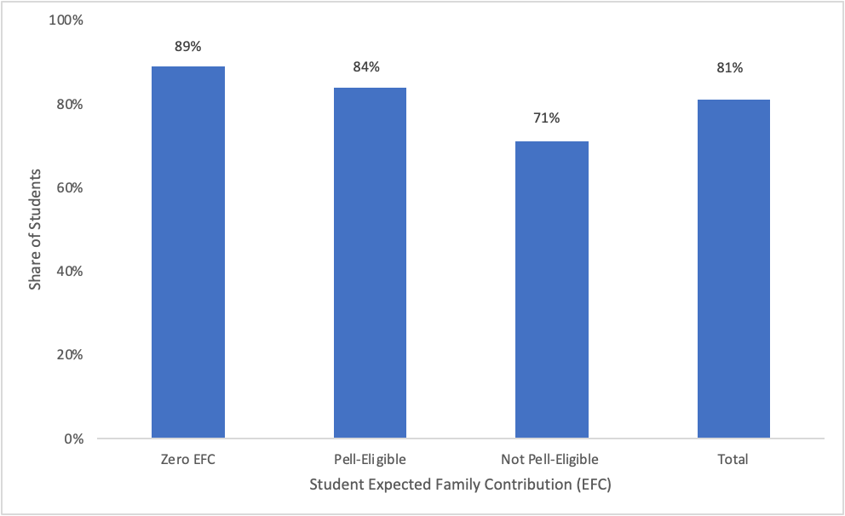
Note: Pell-eligible is defined as students with an EFC above zero but equal to or below the maximum Pell Grant eligibility EFC of 6656. The Not Pell-eligible column is students with an EFC above 6656.

QUOTES
"My biggest challenge I think is being the first member of my family to attend college and worrying about the financial needs to pay [for] my education."

"My parents can't afford to pay for any of [college] at all, and so I'll have to figure out loans and everything else, and especially since I don't have a job yet, I'm getting really stressed out about how I'm going to deal with cost, even though I'm going to one of the cheapest schools I could have gone to."

How HS Students Learned About FAFSA/CADAA
The majority of students identified high school staff (81%) as their primary source for learning about the importance of completing a financial aid application. Other common sources of information were word of mouth (28%), print media (20%) and financial aid workshops (11%). Few students reported learning from other sources including online websites and public service announcements.

Figure 2. Sources of Information about Financial Aid

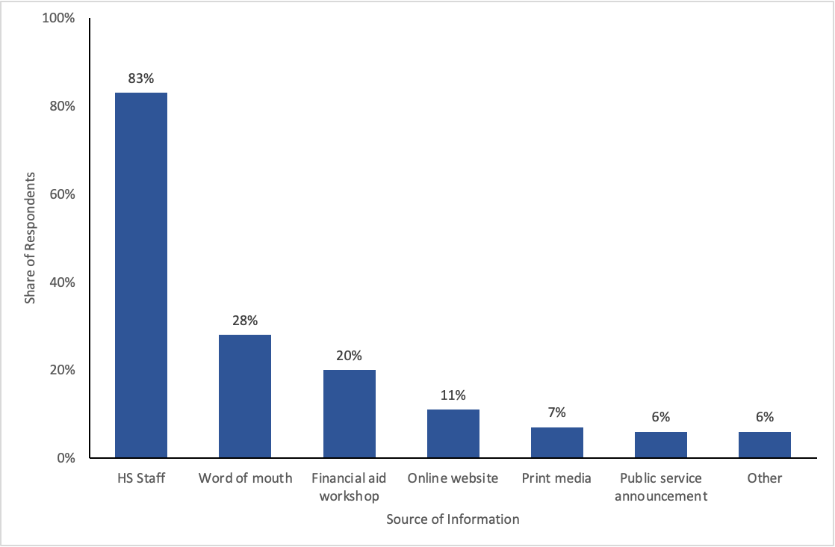

Supports for Completing the FAFSA/CADAA

When asked about support in submitting the FAFSA/CADAA, approximately half of students indicated receiving parental help (Figure 3). Other common sources were high school counselors (45%), financial aid workshops at high schools (30%), and friends (22%).

There were some differences in FAFSA/CADAA support by income (Figure 3b). Only 29% of students with a zero EFC reported their parents helped them with the FAFSA/CADAA, compared to 71% who were not Pell-eligible. Students with the lowest EFC were more likely to have assistance from high school counselors (54%) compared to their higher-income peers (34%). Students with lower EFC were also more likely to report support from financial aid workshops hosted at their high school.

Figure 3. Sources of Support in Submitting FAFSA/CADAA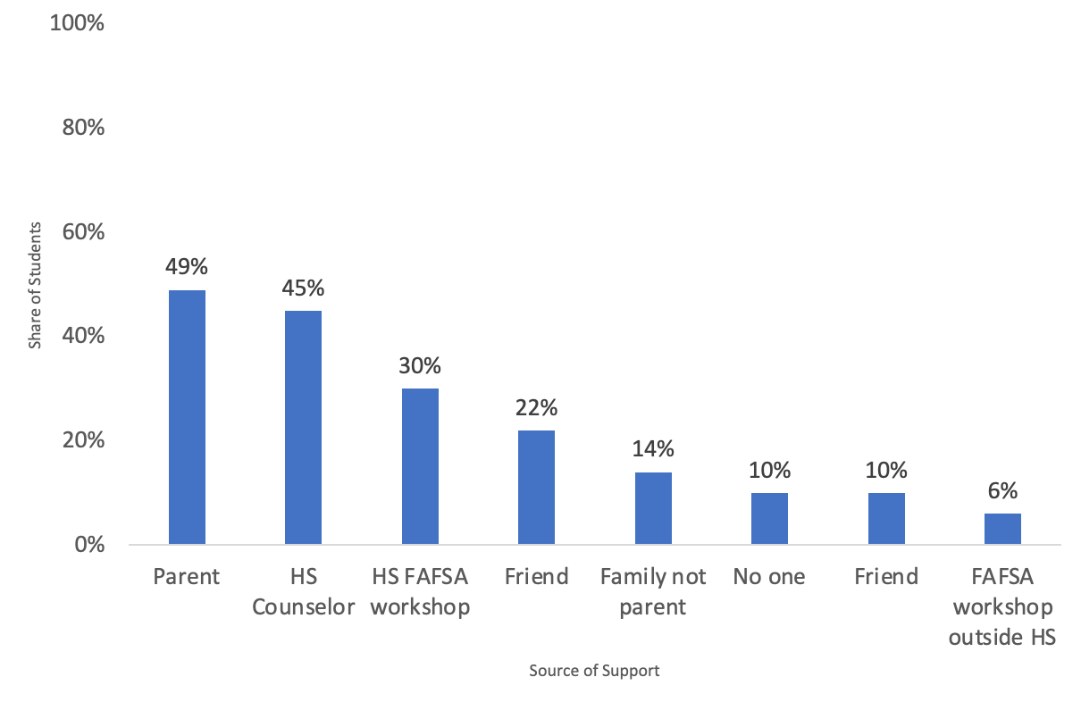

Figure 3b. FAFSA/CADAA Support by EFC

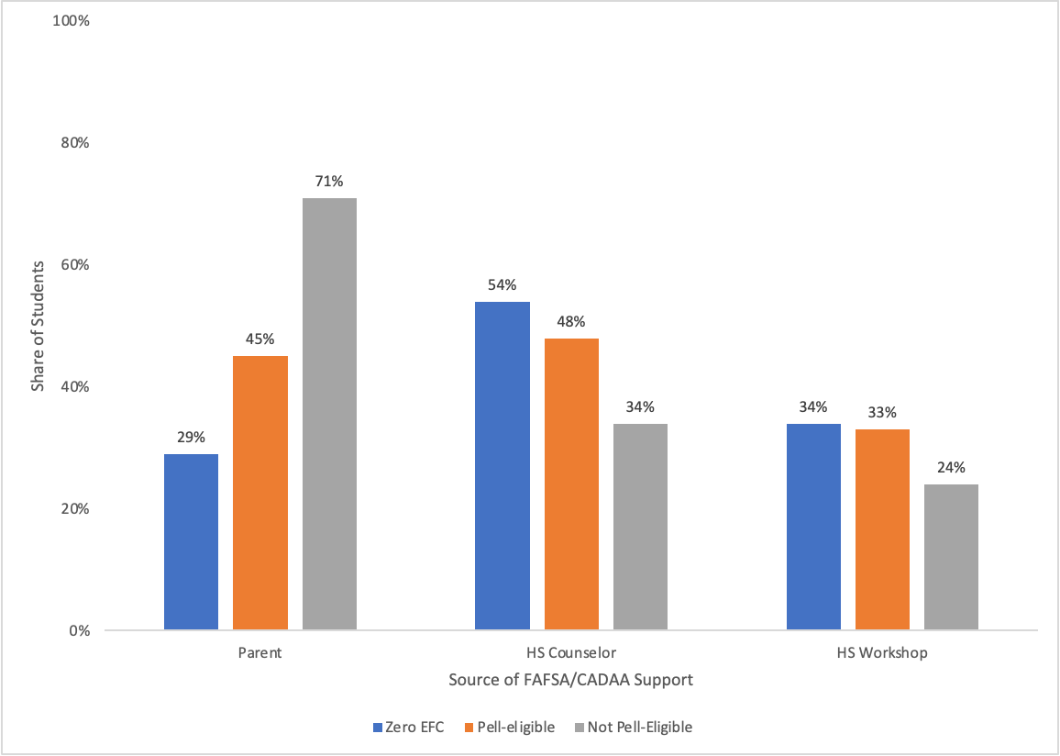

QUOTE
"I'm scared about payments I'll have to make because my college's living expense is very high. I'm also the first to go to college (4 year) in my family, so I've had to do a lot by myself but the counselors were helpful. I'm scared that [the] level of help won't be there at my college since there is so much more students they'll focus on."

We also explore differences by race because income is not evenly distributed across race/ethnicity. For instance, more Latinx and Black students are lower-income compared to White and Asian students — only 27% of Black students and 19% of Hispanic students are not Pell-eligible compared to 58% of Asian and 69% of White students. Therefore, instead of showing raw differences by race, we present results that show racial differences within each EFC category. While we report differences for Asian students, it’s important to note that “Asian” is a broad race category that can represent many ethnic groups — each with their distinct history and educational experiences (Zhou, 2021). This broad categorization can mask educational inequities for racial groups when analyzed collectively (National Center for Education Statistics, 2019)

Even when comparing students with the same EFC, there are striking differences in sources of FAFSA/CADAA support by race (Appendix Figure A1). Only 22% of the lowest-income Latinx students reported their parents helping them submit the application, compared to 38% of Asian and almost half of White students. A higher share of Latinx (58%) and Black (51%) students report receiving help from a high school counselor, compared to their Asian and White peers, and these trends hold true across income categories.

Figure 3c FAFSA/CADAA supports by Race and EFC

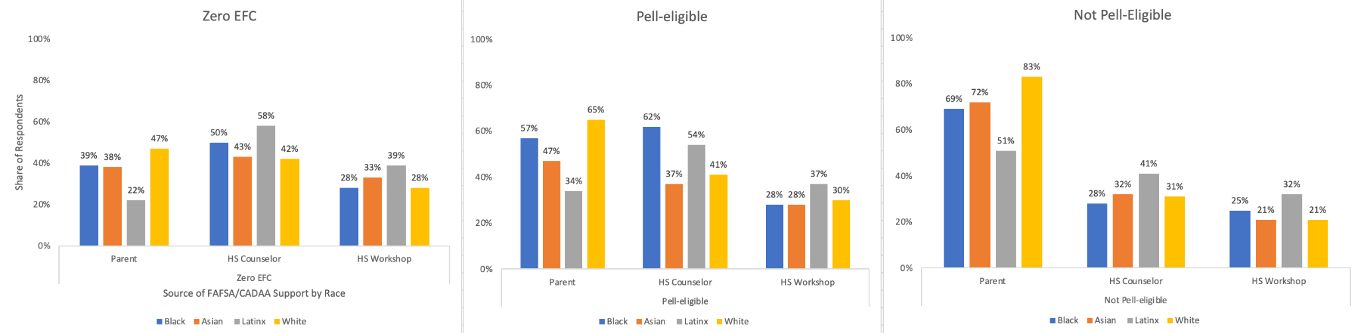

College Plans
The questions from the previous analyses were asked of all survey respondents. But the following college-related questions were only asked of the 95% of survey respondents who indicated that they planned to enroll in college in Fall 2023. Where students planned to enroll varied significantly by student income (Figure 4). Low-income students were much more likely to state their intended plans to enroll at a California Community College (CCC), and higher-income students were much more likely to indicate their plans to enroll at a University of California (UC) campus (29%) compared to students with a zero EFC (15%). Rates of California State University (CSU) attendance were fairly stable across income groups.

Figure 4. Planned College Segment by EFC

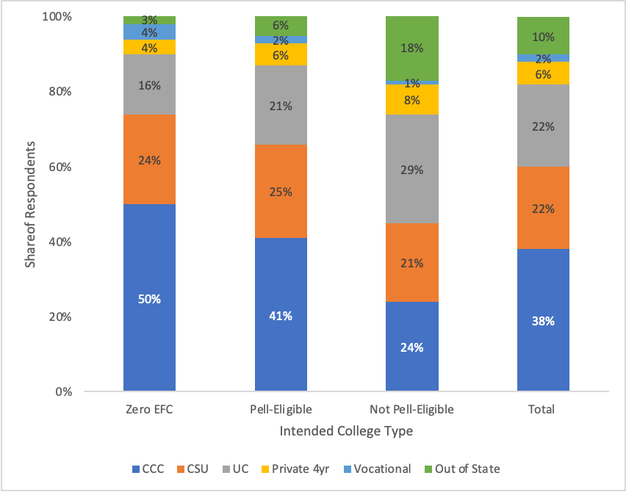

There are large differences in planned college enrollment by race across all income categories. Across all income categories, a higher share of Latinx students planned to enroll at a CCC instead of a four-year institution. Even among the highest-income students, over 40% of Latinx students planned to enroll at a CCC, compared to 20% of White students and only 12% of Asian students. Higher-income Latinx students were also much less likely to plan to attend a UC (16%) compared to their White (24%), Black (37%) and Asian (50%) peers.

Figure 4b. Planned College Segment by Race x EFC
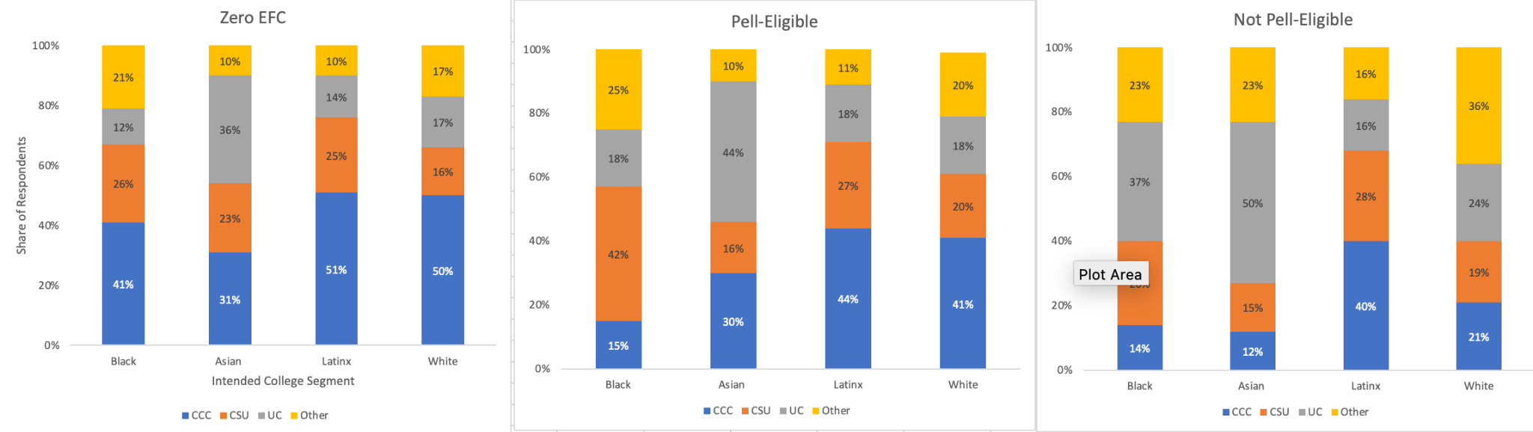
Note: “Other” combines private four-year institutions, vocational programs and out-of-state institutions because of cell size restrictions.

College Communication About Financial Aid
The survey also asked students questions about what communication they had received from colleges about financial aid. Nearly three-quarters of students said their college contacted them about their financial aid. The most common reason students were contacted was about their financial aid award offer letter (67%), and just over half of students reported that they were notified that they had been flagged for verification and needed to provide additional documentation before they could receive aid. Other reasons for contact were information about loans (43%) and work study (29%).

College communication about financial aid varied substantially by where students planned to enroll in the fall. Figure 5 shows that almost 90% of students planning to attend UC and 81% of those planning to attend CSU reported that their college had contacted them about financial aid. But only 56% of students planning to attend a CCC had been contacted about their financial aid.

QUOTE:
"I don't know how much financial aid I will get, and I am not sure if I will be able to attend college for that reason" (Latinx female planning to attend a CSU)

"I believe that I will struggle financially in college because being a DREAMer limits me from so many opportunities and I am not quite sure if I will be receiving financial aid for college."

Figure 5. College Contact for Financial Aid by Segment

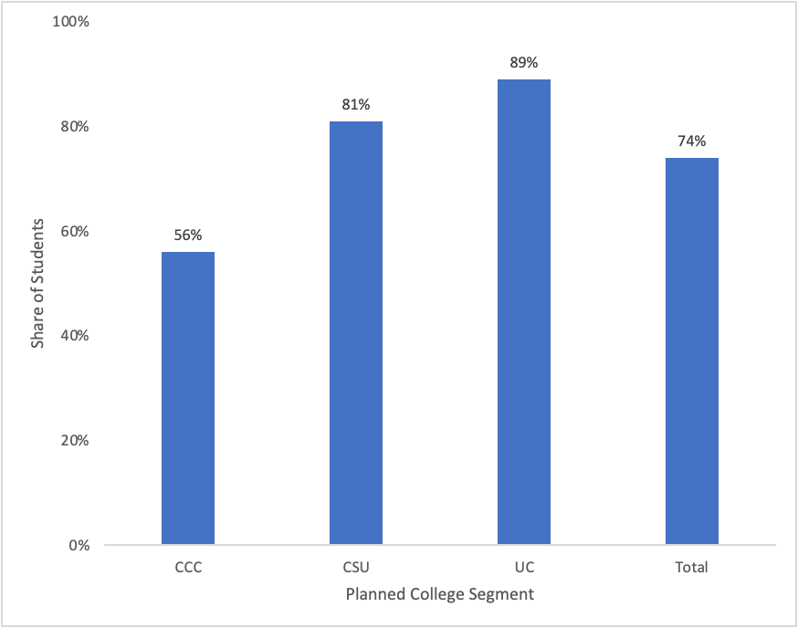

Financing college
Students planning to enroll in college in Fall 2023 planned to pay for college in a variety of ways (Figure 6), including need-based grants (50%) like the Pell Grant and Cal Grant, scholarships (51%), their own savings (35%), loans (33%) and money from other people (44%). Over half of students also planned to work while enrolled in college to finance their education.

Figure 6. Methods for Paying for College
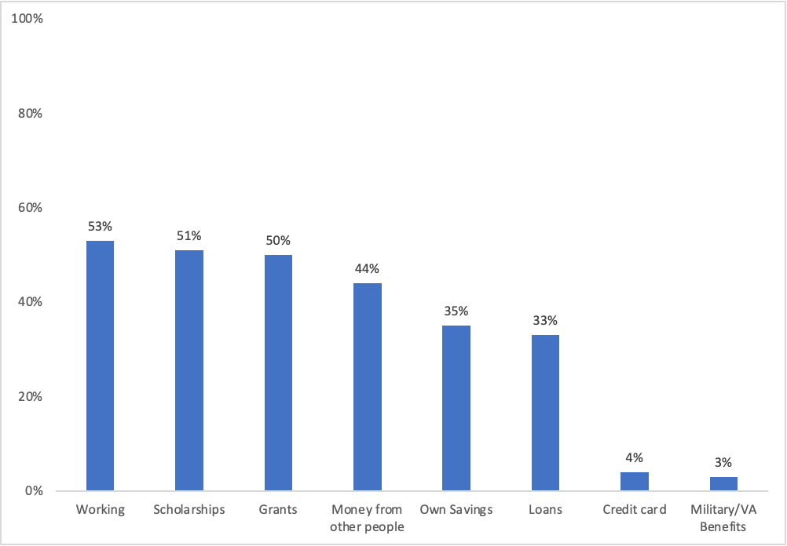

There were also substantial differences by student income (Figure 6b). While students across the income distribution showed similar rates of planning for grants, scholarship and working while enrolled, higher-income students were more likely to report relying on money from other people (68%) and loans (41%) when compared to their lower-income peers.

Figure 6b. Methods of Paying for College by EFC
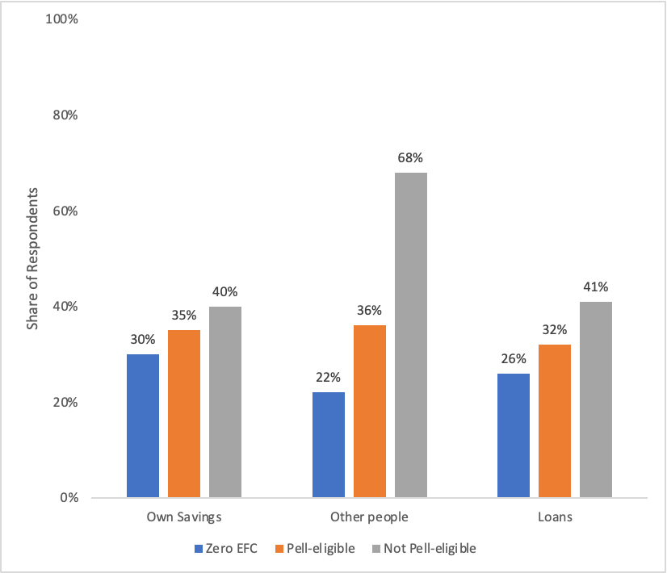
Figure 6c shows differences by race among the lowest-income students with zero EFC. Asian students were much more likely (38%) to report relying on money from other people compared to 25% of White students, 26% of Black students, and only 19% of Latinx students. Approximately half of Black, Asian and White students planned to work to pay for college, but this was even higher for Latinx students (60%). Latinx students were also the least likely to report planning to take out loans.

Figure 6c. Methods of Paying for College by Race among Zero EFC Students
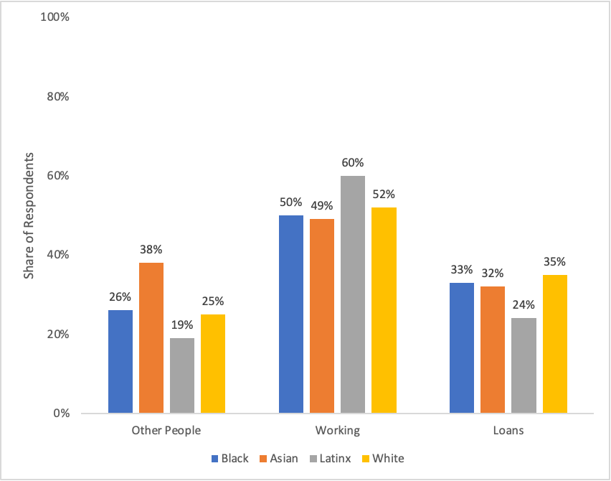

Figure 6d also shows some notable differences by higher education segment. Students planning to attend the UC were much more likely to rely on loans (39%) and scholarships (62%) compared to students planning to enroll at the CCC or CSU. Notably, only 47% of students planning to attend CCC were planning to receive need-based grants to finance their education.

Figure 6d. Methods for Paying for College by Segment

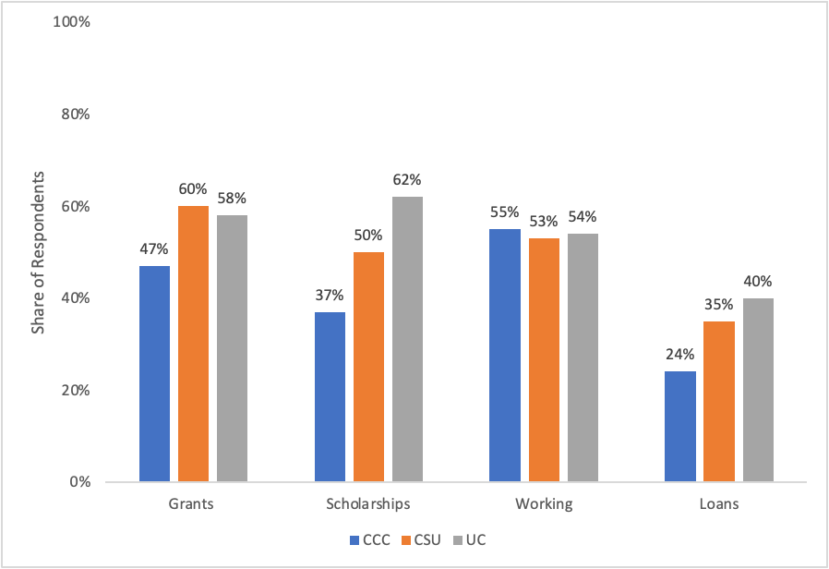

What Students Are Most Worried About?

QUOTE

"I'II miss my high school life, but more importantly than that is money. We are receiving zero financial aid even though I have a single mother supporting two kids at home and it's going to be really hard for her to afford my education. I'lI feel really guilty about that. I'm working a minimum wage job trying to save up money to help pay but I'll barely make a dent in all the payments even with my entire life's savings."

Figure 7 shows that students are concerned about the financial aspects of pursuing higher education. The majority of students expressed that they were somewhat or very worried about being able to cover tuition/fees (63%), paying for living expenses (58%) and balancing work obligations (51%).

Figure 7. Financial concerns
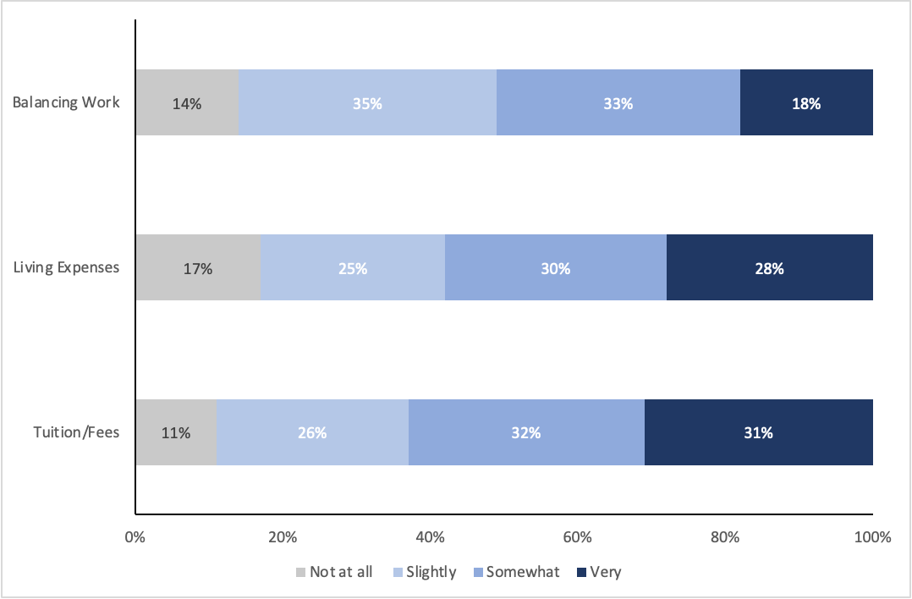

This concern was especially pronounced among lower-income students. Figure 7b shows that over a third of all Pell-eligible students were very worried about paying tuition and fees, but even 26% of higher-income students still expressed significant concern. There were similar patterns for paying for living expenses, with a higher share of low-income students very worried, and still over 20% of higher-income students showing similar concern. Finally, 21% of all Pell-eligible students (including zero EFC) were very worried about balancing work obligations with school.

Figure 7b. “Very Worried” Responses for Financial Concerns by EFC
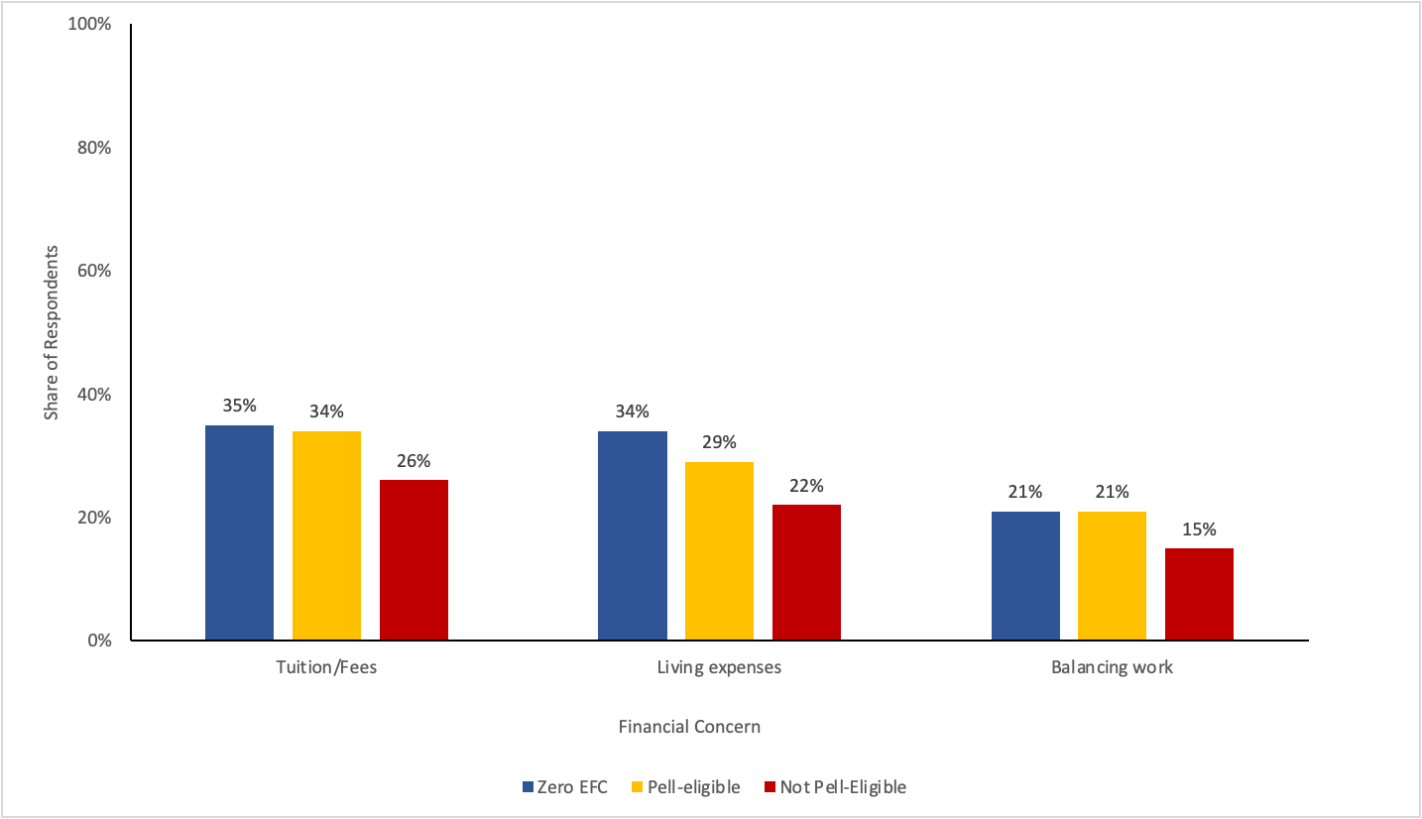
Note: this shows the distribution of students who reported they were “very worried” by EFC.

Financing College: High School Seniors Voice Their Concerns

At the end of the survey, students were asked “What do you think is the biggest challenge you’ll face in college?” Over 6,100 (67%) students responded to this question and nearly 1 in 4 mentioned some aspects of affordability or concerns about the costs of college.

Several themes emerged that referenced affordability, with work obligations and cost of attendance as frequently cited concerns. Other themes were student debt, transportation, familial obligations, and general financial uncertainty. Yet many students reported a series of compounding concerns regarding affordability and how that impacts their transition to college. As exemplified by one student’s reflection:

"I'm worried about the financial challenges I'II face. I'll need to think about food, working, and managing my time and money. It's a lot. I'll be overwhelmed at first and won't be sure about anything. I'll need to worry about multiple things, not just my education or grades."

Students described concerns for finding, maintaining, and/or balancing a job while a student, with responses such as: “balancing my job with school;” “I need to find work to pay off my bills while in school;” “establishing personal finance security.” The general trepidation of keeping up with the cost of attendance was conveyed with responses about concerns in keeping up with payments like housing, paying tuition, and buying books and supplies (e.g., “not being able to afford it” or “paying rent and tuition”). Other students described their worries about not qualifying for or receiving aid to finance their college enrollment; for example, “I received no FAFSA, so I don’t know how my family and I will pay for college” or “I receive nothing in aid, and my parents can't afford to send me to college.”

Students described concerns about affording to live while in college and covering basic necessities, such as food and transportation, with comments such as: “I worry about paying for meals” or “Paying for food.” Others described concerns to cover gas, maintenance on their car, public transit, or being able to afford airfare tickets to go back home.” For some students, this extended to concerns in continuing to support their families while in school, including the need to send money home. “The biggest challenge I'll face in college will have to be financially more than anything because both my parents are unemployed.”

“My biggest challenge I think I would face is financially at home and school. As well trying to balance my work life, social life and home life. But the most challenging is the financial responsibility for my family” (CCC-bound Latinx female)

Finally, many students conveyed concerns about accumulating debt and paying back loans after graduation with responses such as:“My biggest concern is debt;” or “I’m worried about paying off what I owe after I’m done.” Another student expressed, "Considering I am a first generation immigrant with parents that make an income that is considered below average, paying for tuition, books, and other of my college endeavors would be a struggle to pay for. Though I am well qualified for financial aid (fafsa and cal. grants), paying for the subsidized loans is quite worrisome and what I consider is the biggest challenge."

Conclusion
Results from this survey of California high school seniors from the Class of 2023 provide important insights into how high school seniors experience the financial aid process and plan for college. In light of the new FAFSA/CADAA requirement in high school, it is reassuring that over 80% of students were aware that they were required to submit the application. This is also a self-reported measure; it is likely additional students were instructed to submit the application in a different way (e.g. through an AVID or other college preparatory course or program) without realizing it was a high school mandate.

The sources of support students received in completing the FAFSA/CADAA varied by both income and race. Lower-income students relied more on high school counselors and FAFSA workshops for help in completing their applications while their higher-income peers were more likely to rely on parental support. Notably, Latinx students were least likely to report parental support in completing their aid application across all income categories. Even within the same income range, Latinx students were more likely to rely on high school counselors and workshops, while White and Asian students reported more parental support. These differences should not be interpreted as a lack of interest from Latinx parents but rather continued information barriers that many Latinx families experience in supporting their children’s schooling, despite the similarly high as value placed on their children’s college education (Stepler, 2016; UNIDOS US, 2022)). An additional hurdle might be due to students with mixed-status families, in which the students are U.S. citizens but the parents may not be (NCAN, 2024). These differences by subgroup highlight the critical importance of ensuring high schools are providing the necessary personnel to help students with the FAFSA/CADAA (and other college application processes) - especially for minoritized populations in order to address the persistent racial equity gaps in college access and completion (Greene & Popppe 2022; Poppe, 2020, Rendón et al., 2012).

Our survey results also show a significant gap in communication from financial aid offices by college segment (type). While the majority of students planning to enroll at a UC or CSU had some contact from the financial aid office of their intended college, only half of students who planned to attend a CCC had received such contact. By May of their senior year, many high school students were making decisions about if and where to enroll in college, and an important part of this decision-making is communication from colleges about financial aid packages (Kim et al., 2019). Students planning to attend a four-year institution must formally apply in the fall of their senior year. In contrast, the CCC has a rolling application process, so it is possible that some of the students intending to enroll at a CC had not yet completed the CCC application - or even listed their intended community college campus on the FAFSA/CADAA. Nevertheless, even with the CCC’s rolling admissions, this late spring period is a crucial time for students to be making college decisions. If students do not have a full and accurate picture of how they can pay for college, it can likely dampen the likelihood of their enrollment. This is especially concerning given that the CCC disproportionately enrolls more first-generation, lower-income, and students of color than the public four-year systems (CCCCO, 2020).

Equally concerning is that over half of students reported being flagged for verification, as some students may not receive their aid if they do not have the knowledge or resources to navigate the process (Rodriguez & Szabo-Kubitz, 2024). All this information must be completed before a student can receive their financial aid, but the verification process can be complex and lengthy, resulting in a significant barrier even for students who have already successfully submitted a FAFSA (Evans et al, 2019).

These results also showed a wide range of how students planned to pay for college upon enrollment. Notably, less than half of students planning to attend CCC were planning to receive need-based grants to finance their education- despite the CCC enrolling a higher share of low-income students compared to the CSU and UC. This could partially be due to lack of knowledge about aid among CCC students, as evidenced by their lower overall communication about financial aid. Thus, it is possible that some students would be receiving Pell Grants or other state aid closer to when the fall term began.

Overall, over half of students in our sample expressed concerns about affording tuition, living expenses, and balancing work while in college This was especially pronounced among the students with zero EFC. Further exploration through open-ended responses unveiled an expansive set of concerns regarding college affordability that students grapple with, including balancing work and school, covering basic needs and familial obligations, and fear of accruing debt.

Statewide financial aid submission requirements can increase application completions and college enrollment without negatively impacting high school graduation rates, yet challenges with equitable implementation can limit the policy’s full potential (Denault 2023; Sandoval, 2023). Our results are important for policymakers and practitioners to consider, as the new FAFSA/CADAA requirement needs to be coupled with equitable support systems to alleviate information barriers for students and strengthen policy pathways to greater college affordability..

References
Adan, S. & Friedmann, E. (2021). FAFSA National Scan.

Assembly Bill No. 469 Pupil Instruction: Financial Aid Applications. (2021). California Legislative Information. https://leginfo.legislature.ca.gov/faces/billNavClient.xhtml?bill_id=202120220AB469

Bahr, S., Sparks, D. & Hoyer, K. M. (2018). Stats in Brief: Why Didn’t Students Complete a Free Application for Federal Student Aid (FAFSA)? A Detailed Look (pp. 1–22). National Center for Education Statistics. https://nces.ed.gov/pubs2018/2018061.pdf

Bettinger, E. P., Long, B. T., Oreopoulos, P. & Sanbonmatsu, L. (2012). The Role of Application Assistance and Information in College Decisions: Results from the H&R Block Fafsa Experiment. The Quarterly Journal of Economics, 127(3), 1205–1242. https://doi.org/10.1093/qje/qjs017

Deneault, C. (2023). College Enrollment and Mandatory FAFSA Applications: Evidence from Louisiana. American Economic Journal: Economic Policy, 15(3), 465–494. https://doi.org/10.1257/pol.20210360

Dynarski, S., Page, L. & Scott-Clayton, J. (2022). College Costs, Financial Aid, and Student Decisions. National Bureau of Economic Research, 1–63. https://doi.org/10.3386/w30275

Elengold, K. S., Dorrance, J., Martinez, A., Foxen, P. & Mihas, P. (2021). Dreams Interrupted: A Mixed-Methods Study Assessing Latino College Completion (pp. 1–47). The University of North Carolina-Chapel Hill ; UNIDOS US. https://www.unidosus.org/wp-content/uploads/2021/09/unidosus_unc_dreaminterrupted.pdf

Evans, B., Nguyen, T., Tener, B., and Thomas, C. (2017). Federal Pell Grant eligibility and receipt: Explaining nonreceipt and changes to EFC using national and institutional data, Journal of Student Financial Aid, 47 (3), 45-69

FAFSA Pell Eligibility and SAI Guide (pp. 1–49). (2024). U.S. Department of Education’s Federal Student Aid. https://fsapartners.ed.gov/sites/default/files/2024-01/20242025FAFSAPellEligibilityandSAIGuide.pdf

(GEN-23-02) Federal Pell Grant Payment and Disbursement Schedules. (2023). U.S. Department of Education’s Federal Student Aid https://fsapartners.ed.gov/knowledge-center/library/dear-colleague-letters/2023-01-26/2023-2024-federal-pell-grant-payment-and-disbursement-schedules

Green, V. L. & Poppe, S. V. (2021). Understanding Systemic Racism and Resulting Inequity in Latino Communities (pp. 1–40). UNIDOS US. https://unidosus.org/wp-content/uploads/2021/08/unidosus_systemicracismpaper.pdf

Indicator 27 Snapshot: Attainment of a Bachelor’s or Higher Degree for Racial/Ethnic Subgroups. (2019). National Center for Education Statistics. https://nces.ed.gov/programs/raceindicators/indicator_rfas.asp#:~:text=Among%20Asian%20subgroups%2C%20the%20percentage,earnings%20and%20higher%20employment%20rates.

Kim, J., DesJardins, S. L. & McCall, B. P. (2009). Exploring the Effects of Student Expectations about Financial Aid on Postsecondary Choice: A Focus on Income and Racial/Ethnic Differences. Research in Higher Education, 50(8), 741. https://doi.org/10.1007/s11162-009-9143-x

Latino Student Success: Advancing U.S. Educational Progress for All. (2022). UNIDOS US. https://unidosus.org/wp-content/uploads/2022/07/UnidosUS_Latino-Education_2022.pdf

Luna, D. & Nellum, C. (2024). https://collegecampaign.org/wp-content/uploads/2024/03/2023_AEEIEA_Briefs_AdvaEquFinAidApp_web.pdf

Poppe, S. V. (2020). Following Their Dreams in an Inequitable System: Latino Students Share Their College Experience (pp. 1–64). UNIDOS US. https://unidosus.org/wp-content/uploads/2021/07/unidosus_followingtheirdreams_lr.pdf

Rendón, L. I., Dowd, A. C. & Nora, A. (2012). Priced Out: A Closer Look at Postsecondary Affordability for Latinos (pp. 1–30). President’s Advisory Commission on Educational Excellence for Hispanics. https://vtechworks.lib.vt.edu/handle/10919/100548

Renewing the Dream: Improving Financial Aid & College Affordability for California’s Undocumented Students (pp. 1–49). (2023). California Student Aid Commission (CSAC). https://www.csac.ca.gov/sites/main/files/file-attachments/renewing_the_dream_full_report.pdf?1677607402

Rodriguez, E. & Szabo-Kubitz, L. (2024). Equitable College Affordability Policies and Practices (pp. 1–38). The Institute for College Access & Success (TICAS) & Campaign for College Opportunity. https://ticas.org/wp-content/uploads/2024/03/Equitable-College-Affordability-Policies-and-Practicies-CCO-2024_web.pdf

Sandoval, M. (2023). Opportunities & Challenges of Universal FAFSA (pp. 1–20). uAspire. https://www.uaspire.org/getattachment/40c4f21c-2240-4a58-998f-5832789338b5/Opportunities-Challenges-of-Universal-FAFSA.pdf

Steppler, R. (2016). Hispanic, black parents see college degree as key for children’s success. https://www.pewresearch.org/short-reads/2016/02/24/hispanic-black-parents-see-college-degree-as-key-for-childrens-success/#:~:text=Today%2C%2086%25%20of%20Hispanic%20parents,white%20parents%20say%20the%20same.

Universal FAFSA with Supports. (n.d.). National College Attainment Network. Retrieved March 18, 2024, from https://www.ncan.org/page/UniversalFAFSA

Zhou, L. (2021). The term “Asian American” doesn’t serve everyone it covers. https://www.vox.com/identities/22380197/asian-american-pacific-islander-aapi-heritage-anti-asian-hate-attacks

Appendix
Figure A1. EFC by Race

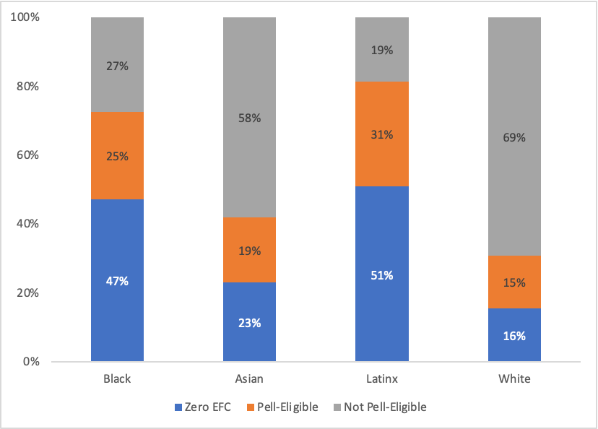

Other quote options:

“I think I will struggle with the financial aspect of college, as I will need to balance the tens of thousands I will spend on tuition and supplies over all 4 years with rent, groceries, and other necessities. I am also worried I won't have much support in the way of finances.”

"I'm worried about the financial challenges I'II face. I'll need to think about food, working, and managing my time and money. It's a lot. I'll be overwhelmed at first and won't be sure about anything. I'll need to worry about multiple things, not just my education or grades."

"I'm scared about payments I'II have to make because my college's living expense is very high. I'm also the first to go to college (4 year) in my family, so I've had to do a lot by myself but the counselors were helpful. I'm scared that level of help won't be there at my college since there is so much more students they'll focus on."

"The biggest challenge I believe I will face in college is not being able to make enough money to send to my family, pay for my education, pay for housing during college, and having the time for a job at the same time as being enrolled in college."

"I think that college would be a big challenge in my life specially because I'm learning a new language English is my second language and also that no one has oriented me on how to enter a college I do not have financial aid or anything and I am also low-income."

"The biggest challenge IlI face is the money aspect and how I will keep myself from accumulating so much debt. I understand that loans will be the main thing that will get me through school. But Im scared that I won't be able to take advantage of my all resources and regret that I didn't do something sooner. This is because I am completely on my own and have no one that has gone through this process to ask for help."

"The biggest challenge i will face in college is paying for the expenses and tuition, as my family is struggling financially. It is uncertain whether i will be able to afford the entire 2 years at the community college and whether i can afford my last two years at a cal state once i transfer."

"I believe that the biggest challenge that I'll have to face in college is finding a balance between my schoolwork and actual work. I am going to have to get at least 2 part-time jobs to help get myself through school so I am hoping that I can find a balance between school and work."

In July 2021, Governor Newsom signed into law Assembly Bill 469, which states that local educational agencies must ensure high school seniors submit the FAFSA/CADAA or opt-out form beginning in the 2022-23 school year (Luna & Nellum, 2024).
Louisiana was the first state to require high school students to complete a FAFSA before graduation but the state Education board removed this requirement in March 2024 (Blake, 2024).
For the 2023-24 academic year, the maximum EFC to be eligible for a Pell Grant was $6,656.
Each year, the Department of Education selects students to verify that the information they submitted on the FAFSA is correct. The information required can range anywhere from a simple signature to a full IRS tax return to prove income. In California, a share of CADAA students are also required to be verified.
All responses to this open-ended question were analyzed to determine if students mentioned college affordability, and then grouped by themes.The thematic codes are not mutually exclusive — meaning that students may have described challenges with more than one theme in their response.

